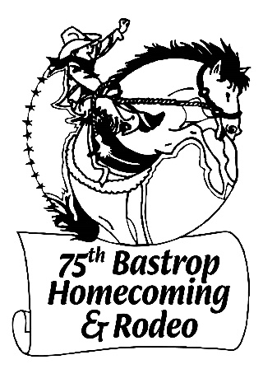

Annual Bastrop Homecoming & Rodeo
Food Vendor Application
August 4-6, 2022

Please fill in the REQUIRED information:
Business Name:________________________________________ Tax ID #:__________________
Business Contact Name:________________________________________
Contact Phone Number:________________________________________
Contact Email Address:_________________________________________
Booth Size:
**Food Vendor Booths are 12’ X 12’ increments. Food trucks will have a “per truck” space. If you need a larger space, this is subject to committee approval and an additional $50 (minimum, per increment) per booth. This decision is made based on limited space and electricity at the event.
Booth size requested (check one): ____ Food Truck ____Food Booth (Vendor Provided Canopy Setup, 12’ X 12’)
**Food Vendor Booths are filled upon receipt of this application, payment, in full, AND a copy of paid food vendor permit from the city of Bastrop on a first come first serve basis. Multiple “same item” vendors are subject to committee approval and may be rejected due to limited space. If vendor is rejected by committee, a full refund will be available. Fee refunds will not be available for any other purpose (including failed city inspection of any kind) once application is approved by the committee.
---------------------------------------------------------------------------------------------------------------------------------------------------------------
**Per City of Bastrop city ordnance 2020-02, City of Bastrop Mobile Food Vendor the following general notes can be found at https://www.cityofbastrop.org/upload/page/0448/docs/Mobile%20Food%20Vendor%20Checklist.pdf :
* No person shall act as a Mobile Food Vendor in the City without a permit issued by the City.
* Mobile Food Vendors must meet all applicable state and local laws and regulations, including but not limited to the Rules.
* Each Mobile Food Vendor shall display at all times in a conspicuous place where it can be read by the general public:
* the City of Bastrop permit under this article [Article 4.04] and permit number
* a health permit from Bastrop County
*a copy of a Texas sales tax and use certificate
* Mobile Food Vehicles must be movable by motorized or non-motorized means.
* Mobile Food Vending Units cannot obstruct driveways or fire lanes.
* Two sandwich board signs may be used on-site during business hours. All other signage must be on the truck or trailer and mounted flush to the surface of the unit.
* Mobile Food Vending Units (Truck, Trailer or Concession Cart) must be movable my motorized or non-motorized means.
* Any Mobile Food Vendor that will be in one location for more than four (4) hours shall provide covered garbage and storage facilities for employee and customer use of sufficient size that refuse is fully contained in a manner that prevents litter and remains insect and rodent-proof.
* See Ordinance 2020-02 for additional code requirements
Obtaining a permit from the City of Bastrop can be done at https://www.cityofbastrop.org/page/plan.mobilefood
Additionally, the City of Bastrop Fire Code Compliance can be found at https://www.cityofbastrop.org/upload/page/0448/docs/Fire%20Mobile%20Food%20Vending%20Requirements.pdf
---------------------------------------------------------------------------------------------------------------------------------------------------------------
Type of Booth requested (Check All that apply):
(these fees are the Bastrop Homecoming and Rodeo fees and are separate from any local, county or state fees required to be a food vendor)
____ No Electricity Required - $150 ____Electricity Required (110V Outlet) - $200
____Electricity Required (OVER 110V Outlet) - $250 ____Water - $50
**The above fees are per event, Thursday through Saturday (August 4-6, 2022), and will not be reduced for Friday/Saturday only. Vendor booths are required to be open for business by 6PM (but may operate beginning at 3PM) and run through midnight each night (Saturday night grounds are open until 1AM). Set up begins Thursday, August 4th at 10AM. Vehicles must be removed from vendor area no later than 5PM on Thursday.
General food merchandise to be sold:
Please provide a brief description of the food items you will be selling (separate vendors cannot share a space and should submit a separate application and fee). If food items are not listed, and a separate vendor is selling that item as approved by the committee, you may be asked not to sell any item not listed on this application. This is to prevent multiple same item sales due to limited space and availability.
__________________________________________________________________________________________________________________________________________________________________________________________________
No alcohol may be sold by any vendor at this event other than alcohol being sold under the Bastrop Homecoming and Rodeo liquor license.
Completed application and payment (money order or cashiers check made payable to Bastrop Homecoming & Rodeo. Credit Card payment available with added fee. Contact vendor email for credit card payment.) should be mailed to:
Bastrop Homecoming Vendor Coordinator
PO Box 215
Bastrop, TX 78602
For information and questions, please email us at vendors.bhr@gmail.com

