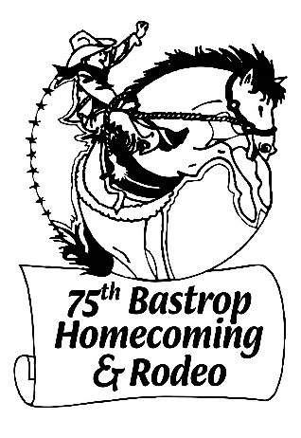
75th Anniversary Sponsorship Levels

August 3-6, 2022

Anniversary Sponsor - $75

Jane Lloyd Sanders Memorial Sponsor - $250
- Listing on Website and Facebook

Mike Mathison Memorial Horseshoe Tournament Sponsor - $500
- Listing on Website and Facebook / Rodeo Announcer Recognition
- Admission to Rodeo and Music Events for 2

Rodeo Event Sponsor - $750
☐Steer Wrestling ☐Calf Roping ☐Barrel Racing ☐Team Roping ☐Bareback ☐Ranch Bronc ☐Bull Riding ☐Kids Events (2 available)
- Listing on Website and Facebook / Rodeo Announcer Recognition
- Admission to Rodeo and Music Events for 2 and 1 Rodeo Arena Banner

Bull Fighters Sponsor - $1500
- Listing on Website and Facebook / Rodeo Announcer Recognition
- Admission to Rodeo and Music Events for 4 and 1 Rodeo Arena Banner

Mayfest Hill Sponsor - $3000+

Listing with logo on Website, FaceBook, poster, movie ad

Rodeo Announcer Recognition

1 Rodeo Box Seat with admission for 8 / 1 Bucking Chute Banner / 2 Rodeo Arena Banners

Banners 4X10 or smaller / Bucking Chute Banner provided by Homecoming

Contact: generalinfo.bhr@gmail.com

Make Payment to Bastrop Homecoming, Inc. and mail to:

Bastrop Homecoming, PO Box 215, Bastrop, TX 78602

www.bastrophomecomingrodeo.org/

